1. **Agenda:**
2. **Terminology**:   
   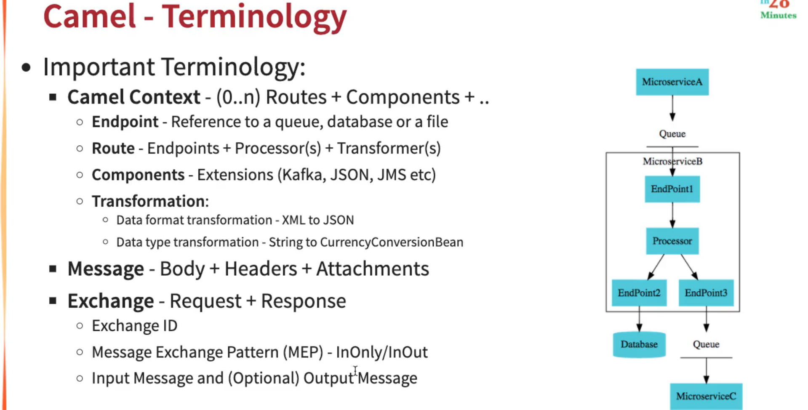
   1. **components**: timer, file, log, activemq etc.
      1. from(“**activemq**:<queue-name>”)
   2. **endpoint**:
      1.   
         
   3. **components:**
      1. camel jar files such for activemq, kafka etc.
3. 